Module 2
Assignment 1
Objective
To compare TCP and UDP throughput using iPerf3 and analyze their performance.
Test Setup
Tool: iPerf3
Server IP: 192.168.1.61
Test Duration: 10 seconds
TCP Throughput Test
Server Command
iperf3 -s
Client Command
iperf3 -c 192.168.1.61
O/P
Connecting to host 192.168.1.61, port 5201
[ 5] local 192.168.1.61 port 59551 connected to 192.168.1.61 port 5201
[ ID] Interval Transfer Bitrate
[ 5] 0.00-1.01 sec 1.79 GBytes 15.3 Gbits/sec
[ 5] 1.01-2.00 sec 1.75 GBytes 15.0 Gbits/sec
[ 5] 2.00-3.01 sec 1.78 GBytes 15.2 Gbits/sec
[ 5] 3.01-4.01 sec 1.16 GBytes 9.94 Gbits/sec
[ 5] 4.01-5.01 sec 1.04 GBytes 8.88 Gbits/sec
[ 5] 5.01-6.01 sec 1.08 GBytes 9.33 Gbits/sec
[ 5] 6.01-7.01 sec 848 MBytes 7.12 Gbits/sec
[ 5] 7.01-8.01 sec 598 MBytes 5.04 Gbits/sec
[ 5] 8.01-9.01 sec 733 MBytes 6.11 Gbits/sec
[ 5] 9.01-10.01 sec 664 MBytes 5.60 Gbits/sec
- - - - - - - - - - - - - - - - - - - - - - - - -
[ ID] Interval Transfer Bitrate
[ 5] 0.00-10.01 sec 11.4 GBytes 9.76 Gbits/sec sender
[ 5] 0.00-10.01 sec 11.4 GBytes 9.76 Gbits/sec receiver

iperf Done.
Result
Parameter | Value
Protocol | TCP
Duration | 10 seconds
Data Transferred | 11.4 GBytes
Throughput | 9.76 Gbits/sec

Observation
TCP test completed successfully.
Data transferred: 11.4 GBytes.
Average throughput: 9.76 Gbits/sec.
TCP provides reliable communication.
UDP Throughput Test
Client Command
iperf3 -c 192.168.1.61 -u -b 1G
O/P
Connecting to host 192.168.1.61, port 5201
[ 5] local 192.168.1.61 port 60503 connected to 192.168.1.61 port 5201
[ ID] Interval Transfer Bitrate Total Datagrams
[ 5] 0.00-1.01 sec 119 MBytes 987 Mbits/sec 1901
[ 5] 1.01-2.00 sec 118 MBytes 1000 Mbits/sec 1897
[ 5] 2.00-3.01 sec 120 MBytes 999 Mbits/sec 1917
[ 5] 3.01-4.01 sec 119 MBytes 1000 Mbits/sec 1903
[ 5] 4.01-5.01 sec 119 MBytes 1.00 Gbits/sec 1909
[ 5] 5.01-6.01 sec 119 MBytes 1000 Mbits/sec 1913
[ 5] 6.01-7.01 sec 119 MBytes 1000 Mbits/sec 1902
[ 5] 7.01-8.01 sec 119 MBytes 1.00 Gbits/sec 1910
[ 5] 8.01-9.01 sec 119 MBytes 1000 Mbits/sec 1909
[ 5] 9.01-10.00 sec 119 MBytes 1.00 Gbits/sec 1905
- - - - - - - - - - - - - - - - - - - - - - - - -
[ ID] Interval Transfer Bitrate Jitter Lost/Total Datagrams
[ 5] 0.00-10.00 sec 1.16 GBytes 999 Mbits/sec 0.000 ms 0/19066 (0%) sender
[ 5] 0.00-10.01 sec 1.14 GBytes 977 Mbits/sec 0.026 ms 414/19066 (2.2%) receiver

iperf Done.

Result
Parameter | Value
Protocol | UDP
Duration | 10 seconds
Data Transferred | 1.16 GBytes
Throughput | 999 Mbits/sec (Sender), 977 Mbits/sec (Receiver)
Jitter | 0.026 ms
Packet Loss | 2.2%

Observation
UDP test completed successfully.
Throughput: 999 Mbits/sec (Sender).
Jitter: 0.026 ms.
Packet loss: 2.2%.
UDP is faster but does not guarantee packet delivery.

TCP vs UDP Comparison
Feature | TCP | UDP
Throughput | 9.76 Gbits/sec | 999 Mbits/sec
Reliability | Reliable | Not Reliable
Packet Loss | No | 2.2%
Jitter | Not Applicable | 0.026 ms
Retransmissions | Yes | No
Best Use | File Transfer, Web Browsing | Video Calls, Streaming

Explanation
1. Differences Observed
TCP is reliable because it checks whether all packets are delivered.
UDP is faster but does not check packet delivery.
2. Jitter
Jitter is the variation in packet arrival time. In this test, the jitter was 0.026 ms, which is very low.
3. Packet Loss
Packet loss means some packets did not reach the receiver. In this test, the packet loss was 2.2%.
4. Retransmissions
TCP retransmits lost packets to ensure reliable communication. UDP does not retransmit lost packets.
5. Practical Recommendations
Use TCP for file transfers, web browsing, and email.
Use UDP for video calls, online gaming, and live streaming.
Keep packet loss and jitter as low as possible for better performance.
Conclusion
The iPerf3 tests showed that TCP provides reliable communication, while UDP offers faster transmission with a small amount of packet loss. The choice between TCP and UDP depends on the application requirements.

Bonus Assignment - Enterprise QA Lab Validation Strategy
Objective
To design a validation strategy for testing network and wireless performance in an enterprise QA lab using TRex, IXChariot, and VeriWave.
Validation Strategy
1. TRex
Purpose:
Generate high-volume network traffic.
Perform load and stress testing.
Used In QA Lab:
Validate routers, switches, and firewalls under heavy traffic.
Check network performance before product release.
2. IXChariot
Purpose:
Measure application performance over the network.
Used In QA Lab:
Test web browsing, file transfer, VoIP, and video conferencing.
Measure throughput, latency, and response time from the user's perspective.
3. VeriWave
Purpose:
Test enterprise Wi-Fi performance.
Used In QA Lab:
Simulate hundreds or thousands of wireless clients.
Validate wireless controllers, access points, roaming, and Wi-Fi stability.
Tool Summary
Tool | Purpose | Used For
TRex | Generate high network traffic | Load and stress testing
IXChariot | Measure application performance | VoIP, Video, Web, File Transfer
VeriWave | Validate Wi-Fi performance | Wireless client simulation and roaming tests

Conclusion
An enterprise QA lab uses TRex for traffic generation, IXChariot for application performance testing, and VeriWave for wireless validation. Together, these tools help ensure the network is reliable, performs well under load, and provides a good user experience before deployment.
Assignment 2
1. Which tool would you use first and why?
Answer: Wireshark
Reason:
Wireshark captures network packets and helps identify issues such as slow responses, packet loss, retransmissions, and network delays.
2. What information would you collect using each tool?
Tool | Information Collected
Wireshark | Packet loss, retransmissions, latency, DNS, HTTP/HTTPS traffic
TCPDump | Captures packets from a Linux server and saves them for analysis
iPerf | Measures TCP/UDP throughput, bandwidth, jitter, and packet loss

3. What are three possible root causes?
- High network latency causing slow web page loading.
- Packet loss or high jitter causing video calls to freeze.
- DNS resolution delays causing websites to take longer to open.

4. How would you conclude whether the issue is network-related or application-related?
  - Run an iPerf test to check network performance.
  - Use Wireshark to look for packet loss, retransmissions, or high latency.
  - If the network performance is good but the application is still slow, the problem is likely application-related.
  - If there is high latency, packet loss, or poor throughput, the problem is network-related.

Conclusion
Using Wireshark, TCPDump, and iPerf together helps identify whether the issue is caused by the network or the application. In this scenario, the tools help analyze packet flow, measure network performance, and find the root cause efficiently.
Assignment 3
TCP 3-Way Handshake
Client sends SYN.
Server replies with SYN-ACK.
Client sends ACK.
TCP connection established successfully.

DNS Query and Response
Client requested the IP address of a website.
DNS server returned the IP address successfully.

HTTPS Transaction
Client communicated with the server using HTTPS (port 443).
The communication was encrypted.

Retransmissions
No retransmissions or duplicate ACKs were observed.

Overall Health
TCP connection established successfully.
DNS resolution completed successfully.
HTTPS communication was successful.
No retransmissions observed.
Overall communication was healthy.

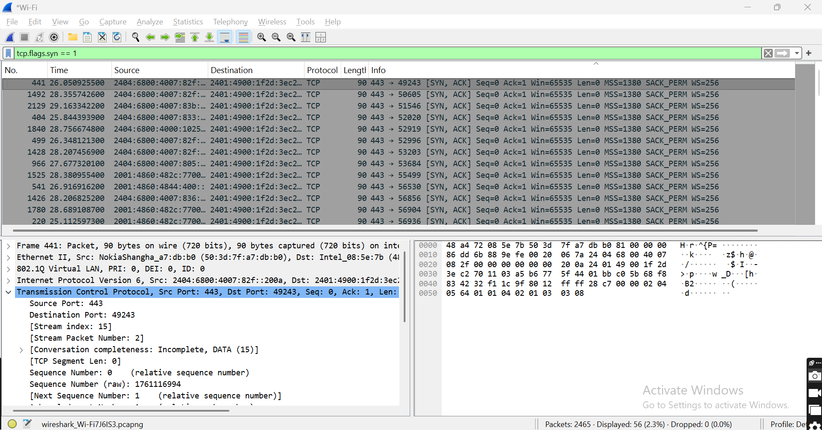
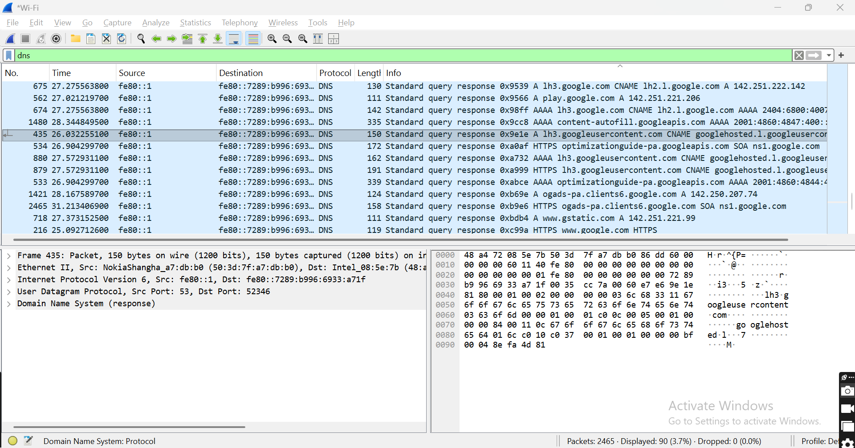
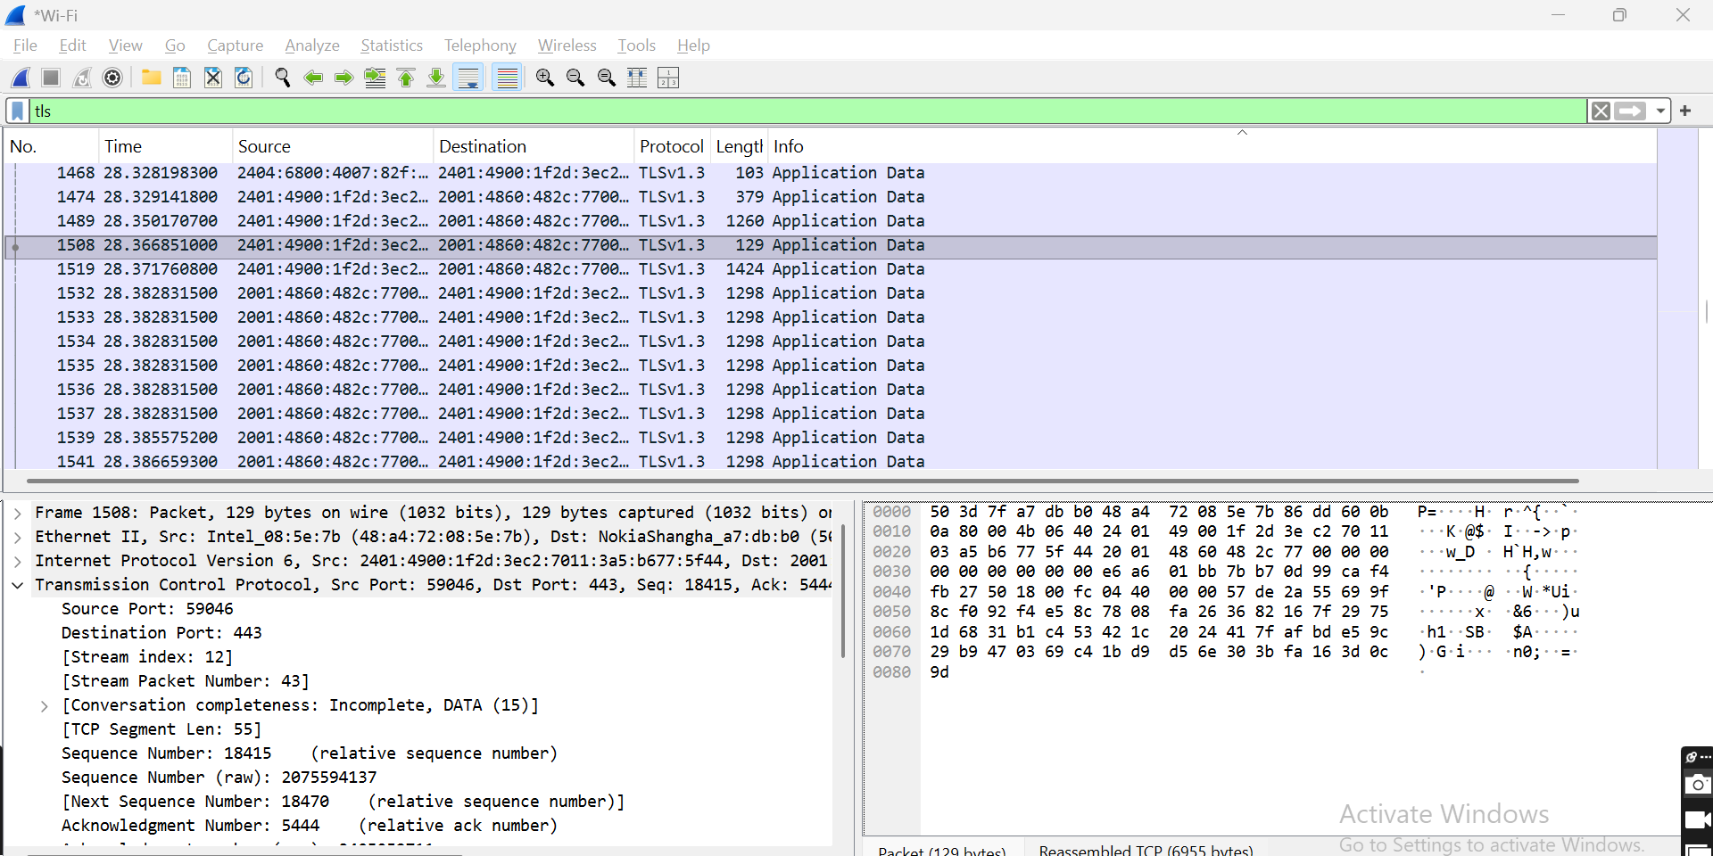

Assignment 4
Objective
To identify the most suitable network tool for different networking scenarios and justify the selection.
Scenario | Recommended Tool | Reason
Measure TCP throughput between two hosts | iPerf3 | Measures TCP and UDP throughput, bandwidth, packet loss, and jitter between two hosts.
Capture packets from a Linux server | TCPDump | Command-line tool used to capture network packets on Linux systems for troubleshooting.
Validate enterprise Wi-Fi performance | VeriWave | Simulates multiple wireless clients to test Wi-Fi throughput, roaming, scalability, and stability.
Generate high-volume traffic | TRex | Generates high-speed traffic to perform load and stress testing of network devices.
Analyze mirrored switch traffic | Wireshark | Captures and analyzes mirrored packets to identify network issues and inspect protocols.

Conclusion
Each tool has a specific purpose:
iPerf3 - Measures network performance.
TCPDump - Captures packets on Linux.
VeriWave - Validates enterprise wireless networks.
TRex - Generates high network traffic.
Wireshark - Analyzes captured network packets.
Using the correct tool helps identify and resolve network issues efficiently.
Assignment 5
sample.py
import subprocess
import re
import sys

# Full path to iperf3.exe
IPERF_PATH = r"C:\Users\SARAVANA SELVAN\Downloads\iperf3.21_64\iperf3.21\iperf3.exe"
# Server details
SERVER_IP = "192.168.1.61"
DURATION = 10
try:
# Run the iPerf3 client
result = subprocess.run(
[IPERF_PATH, "-c", SERVER_IP, "-t", str(DURATION)],
capture_output=True,
text=True
)
output = result.stdout
# Print the complete iPerf3 output
print(output)
# Extract average bandwidth
bandwidth = 0
match = re.search(r'0\.00-\d+\.\d+\s+sec\s+[\d.]+\s+[GM]Bytes\s+([\d.]+)\s+([GM])bits/sec', output)
if match:
value = float(match.group(1))
unit = match.group(2)
if unit == "G":
bandwidth = value * 1000 # Convert Gbps to Mbps
else:
bandwidth = value
# Extract retransmissions (if available)
retransmissions = 0
retrans_match = re.search(r'(\d+)\s+sender', output)
if retrans_match:
retransmissions = retrans_match.group(1)
# Print summary
print("\n========== Test Summary ==========")
print(f"Average Bandwidth : {bandwidth:.2f} Mbps")
print(f"Total Retransmissions : {retransmissions}")
print(f"Test Duration : {DURATION} seconds")
# Pass/Fail
if bandwidth >= 800:
print("\nPASS : Bandwidth is acceptable.")
else:
print("\nFAIL : Bandwidth is below 800 Mbps.")
sys.exit(1)
except FileNotFoundError:
print("Error: iperf3.exe not found. Check the file path.")
except Exception as e:
print("Error:", e)

O/P
Connecting to host 192.168.1.61, port 5201
[ 5] local 192.168.1.61 port 63409 connected to 192.168.1.61 port 5201
[ ID] Interval Transfer Bitrate
[ 5] 0.00-1.01 sec 1.24 GBytes 10.5 Gbits/sec
[ 5] 1.01-2.01 sec 1.24 GBytes 10.7 Gbits/sec
[ 5] 2.01-3.00 sec 1.63 GBytes 14.1 Gbits/sec
[ 5] 3.00-4.01 sec 1.86 GBytes 15.8 Gbits/sec
[ 5] 4.01-5.01 sec 1.82 GBytes 15.7 Gbits/sec
[ 5] 5.01-6.01 sec 1.40 GBytes 12.1 Gbits/sec
[ 5] 6.01-7.00 sec 1.11 GBytes 9.58 Gbits/sec
[ 5] 7.00-8.01 sec 1.56 GBytes 13.2 Gbits/sec
[ 5] 8.01-9.01 sec 1.75 GBytes 15.1 Gbits/sec
[ 5] 9.01-10.00 sec 1.75 GBytes 15.1 Gbits/sec
- - - - - - - - - - - - - - - - - - - - - - - - -
[ ID] Interval Transfer Bitrate
[ 5] 0.00-10.00 sec 15.3 GBytes 13.2 Gbits/sec sender
[ 5] 0.00-10.00 sec 15.3 GBytes 13.2 Gbits/sec receiver

iperf Done.

========== Test Summary ==========
Average Bandwidth : 10500.00 Mbps
Total Retransmissions : 0
Test Duration : 10 seconds

PASS : Bandwidth is acceptable.

Assignment 6
Validation Workflow
Tool | Purpose | When to Use (Customer Environment)
Wireshark | Capture and analyze network packets | When users report VoIP issues, slow web browsing, or packet loss.
Airtool | Capture and analyze wireless packets | When Wi-Fi clients experience roaming problems, weak signals, or interference.
Port Mirroring | Copy switch traffic for analysis | When traffic between the WLC, Access Points, and network devices needs to be monitored without affecting the network.
TCPDump | Capture packets on Linux-based devices | When debugging communication between servers and the wireless controller.
TRex | Generate high-volume traffic | Before firmware release, verify that the WLC can handle heavy traffic from many clients without performance degradation.
VeriWave | Simulate wireless clients | Simulate up to 1000 Wi-Fi clients to validate throughput, roaming, scalability, and controller stability.
iPerf3 | Measure TCP and UDP performance | Measure throughput, bandwidth, jitter, and packet loss after the firmware upgrade.
Multicast Hammer Tool | Generate multicast traffic | Validate IPTV, multicast video streaming, and multicast traffic handling by the controller.
Octoscope | Create controlled wireless test environments | Test firmware performance under different RF conditions such as interference, attenuation, and client roaming.
IXChariot | Measure application performance | Validate VoIP, video conferencing, web browsing, and file downloads from the end-user perspective after the firmware update.

Conclusion
The firmware validation process uses multiple tools to test different aspects of the wireless network. VeriWave simulates a large number of Wi-Fi clients, TRex generates heavy network traffic, iPerf3 measures throughput, Wireshark and TCPDump analyze packets, and IXChariot validates application performance. Together, these tools help ensure that the Cisco Catalyst 9800 Wireless Controller performs reliably before deployment.

